The Monarch’s Way Through Hampshire

The Monarch’s Way is a 625 plus mile footpath which commemorates the route a future King of England King Charles II took in 1651 after his defeat at the Battle of Worcester by Cromwell.

It passes through Hampshire for well over 60 miles entering the county from the west just after passing through Middle Winterslow and leaving the county after Rowlands Castle.
There are many villages and interesting sites along the route through Hampshire, among them are Broughton, Horsebridge, Mottisfont, Michelmersh, Braishfield, Lower Blackstead, Ampfield, Hursley, Shawford Just over a mile from Winchester) , Twyford, Owslebury, Upham, Middle and Lower Preshaw, Lomer, Beacon Hill, Warnford, Old Winchester Hill, Hambledon, Horndean, Rowlands Castle.

The route is shown in the Guide Books where it is broken down into several sections. These are shown on the next pages.

Section 53

MIDDLE WINTERSLOW to MOTTISFONT

12 miles

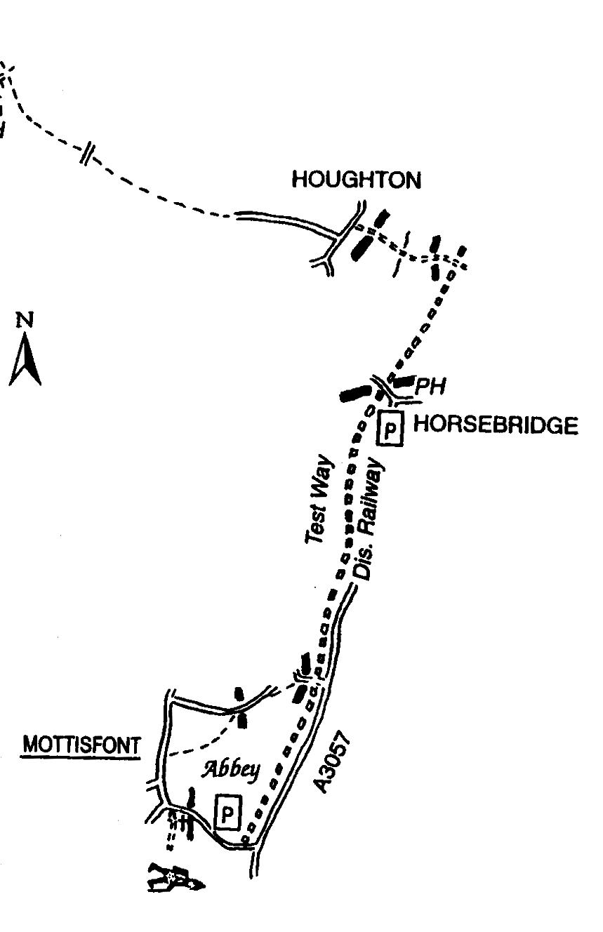
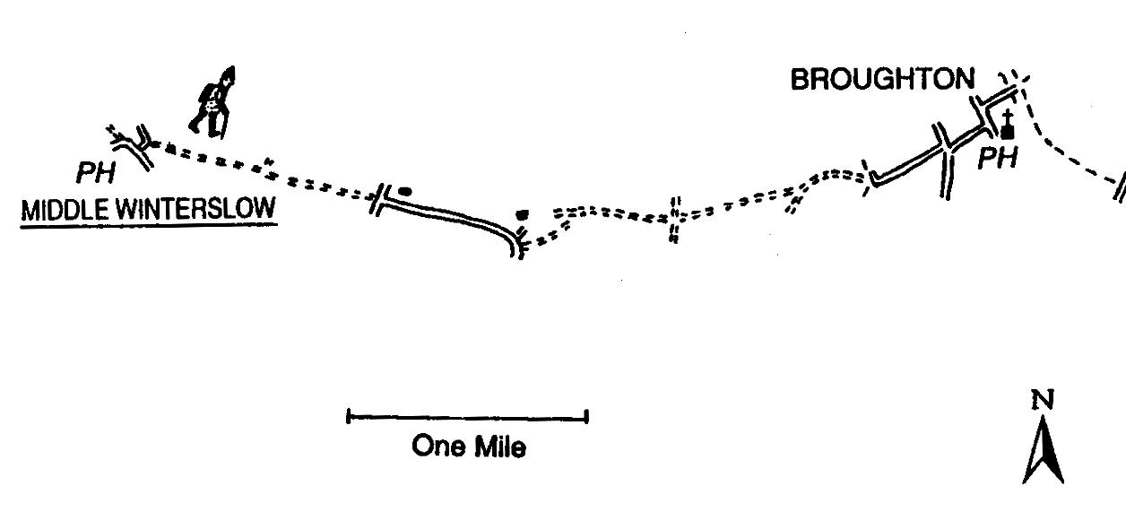

Section 54

MOTTISFONT to HURSLEY

12 miles

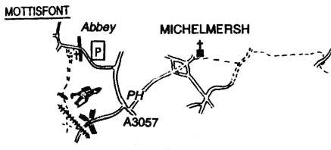

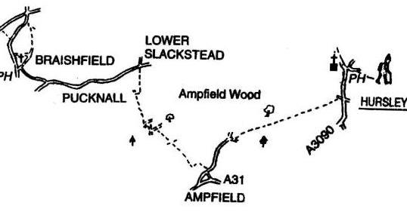

Section 55

HURSLEY to OWSLEBURY

7 miles

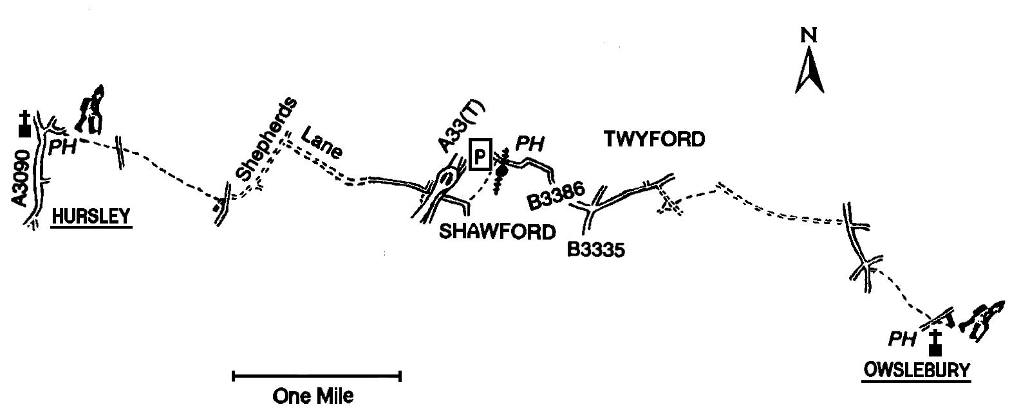

Section 56

OWSLEBURY to WARNFORD

10 miles

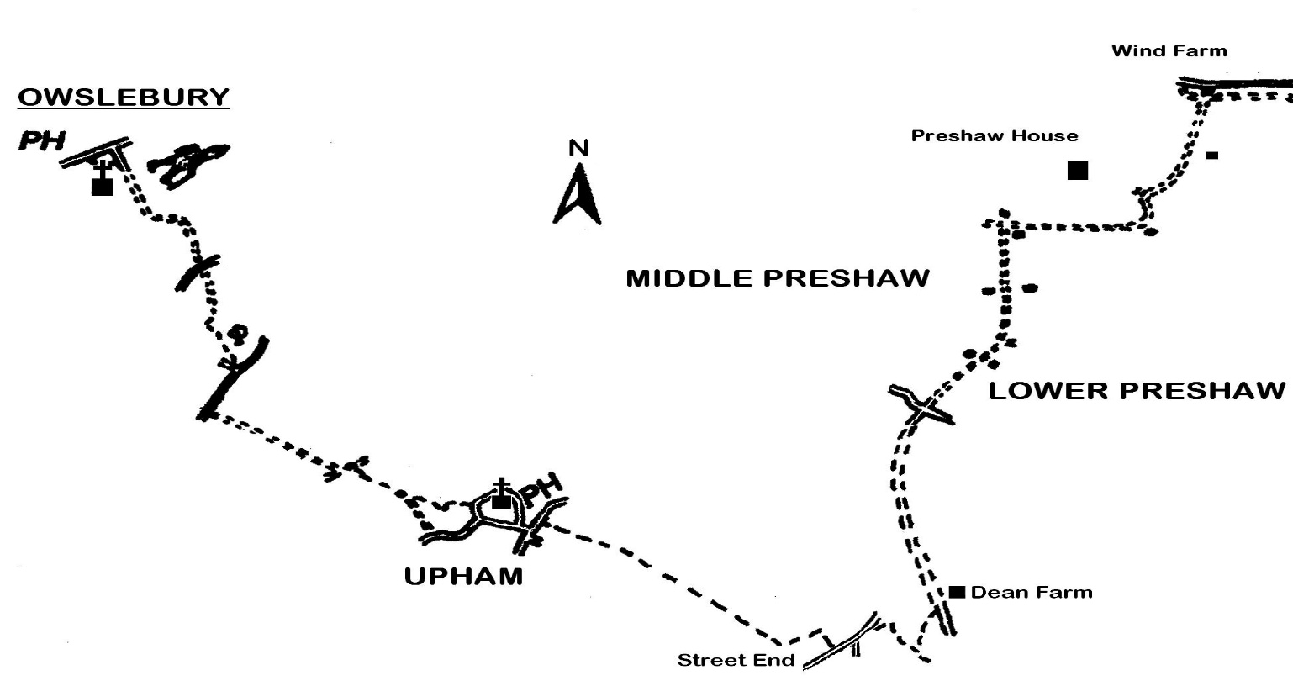

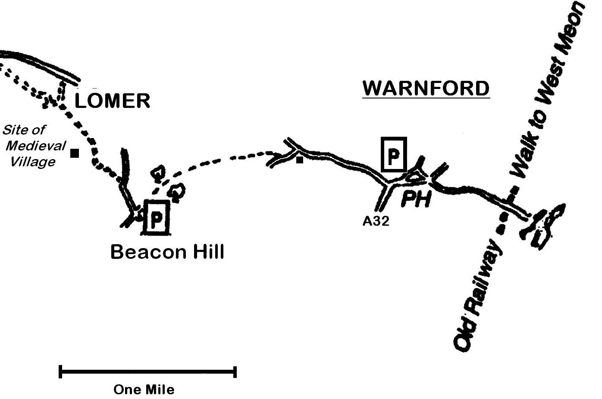

57

WARNFORD to HAMBLEDON

10 miles

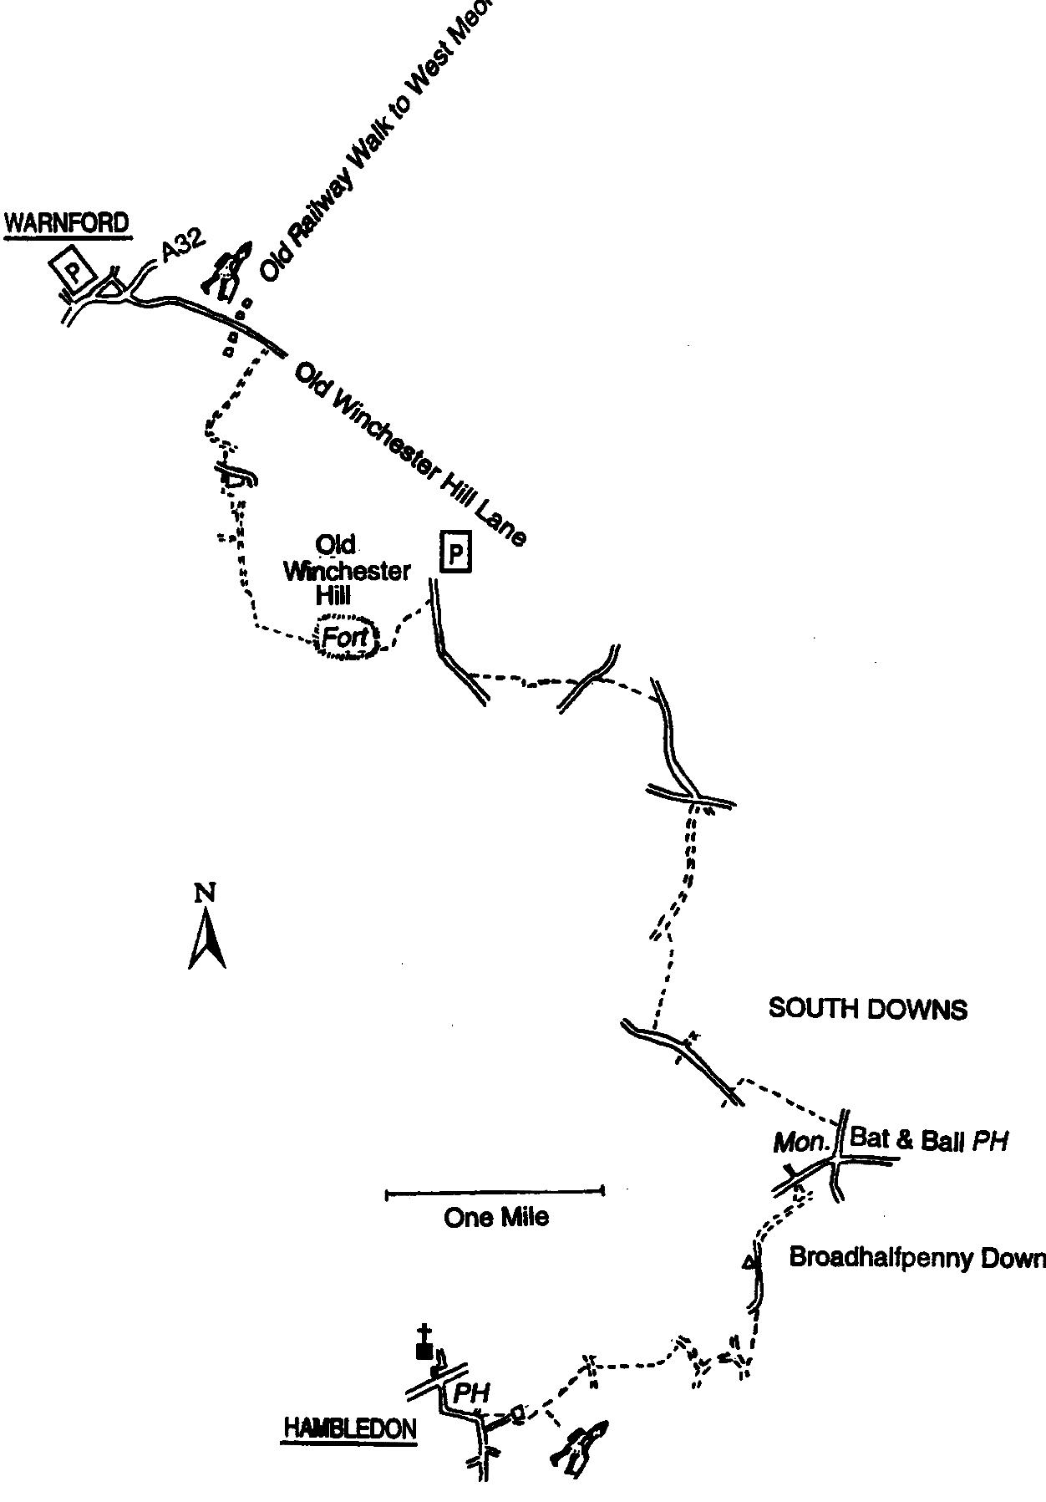

58

HAMBLEDON to ROWLAND’S CASTLE

7 miles

